Discuss how the design, function and content of web pages influence the meaning and value of information?

**Introduction**

In the 21st century, information is everywhere. The world wide web is the most rapidly developing medium in history, it offers a wide range on information presented in a wide rangs of formatis from simple text to animation to live video, and can interact with many of the sources they contact (Eighmey and McCord, 1998, p.189). There are millions of websites on the internet, providing a variety of information and communication facilities, consisting of interconnected networks using standardized communication protocols. Cousumer use of online eresources and information resources is increasing rapidly (Eighmey and McCord, 1998, p.187). Different kinds of information are easily assessable with just the clicks of a mouse or touch of a button. It has become an important part of our lives. It is used for work, entertainment, information, news, education, exploring, surfing and etc. With the excessive amounts of information, sometimes it may be difficult to identify the unreliable ones and be lead astray by false information. There are many vital factors that affects the meaning and values of information provided. This essay will discuss how the design, function and content of web pages influence the meaning and value of information.

**Appearance**

A web site interface is a complex mix of many elements such as text, links, and graphics. Formatting of these elements, and other aspects will affect the overall interface quality and interest (Ivory and Hearst). The design of a website plays an important role in attracting, sustaining and retaining the interest of a visitor at a site and gives them a first impression (Ranganathan and Ganapathy, 2002, p.460). How a website is designed affects the viewers’ interests greatly. The websites design should appeal to the readers’ sense of sight. A website can be dry and boring if it only focus on the content and does not has visual appeal. Many different factors can be used to make a website more interesting and attractive, thus, increases its meaning and value. Using visual communication like colour coordination, layouts formats, images, animation, video, music and other multimedia helps to capture the visitors’ attention (Ranganathan and Ganapathy, 2002, p.460 and Newman and Landay, 2000.p264).

Colour coordination

Layout format

**Navigation**

How effective a function is depended on how the website serves its intended purpose on targeted audiences. Factors that affect a websites’ functions include: straight forward links, language use, The ease of navigation of a website also affects the value and meaning of information it provides. Poor interface functionality is one potential cause for web usability meltdown(Ping Zhang and Gisela, 2000, P.1253). Hyperlinks are used for navigation between webpages. They are a quick way to go around the web. The quality of the navigation structure perceived by web visitors. Hypertext provides the opportunity to build content that is interlligible and interesting to people at different levels of understanding(Eelko, 2000, p.126).

The design and presentation style of the website should stimulate reading and facilitate the interpretation of the information. To stimulate flow, it is important that a similar presentation style is used for all pages within the website (Eelko, 2000 and Ivory and Hearst).The essence of a hypertext environment is that it allows for deep, nonlinear searches initiated and controlled by customers (Eelko, 2000, p.126). Web designers can influence the search by imposing a structure: by adding or omitting links between pages. For hyperlinks, they should be effective so that the less clicks it takes to find certain information, the better. If they user must lick several times and search through many different pages before finally getting where they want, then the website has a weak function as the link does not serve its purpose effectively. However, if a website becomes larger, the hyperlink navigation structure might become cumbersome. To prevent customers from much clicking and jumping from page to page, a search function can lead customers directly to requested information. That is a function that can be used to find specific information within that site.

Some other factors can be used for a easier navigation.

Action buttons solve common problems that customers encounter when navigating on websites: knowing what to click on. Visual illusion works because it takes advantage of what people already know about physical buttons. Add example? (Duyne, 2002)

**Entertainment**

As mentioned before, a websites would be boring if it only has long paragraphs of contents. There should be a balance between the actual content of the website and forms of entertainment. Websites should add in their social media information. This will make the users feel more personally involved with the website and thus are more interested on the website.

**Reliability**

Unreliable websites will have less value and meaning for the information they provide. If the website does not have proper citations or references for where some of their information are from, the website will be seen as less reliable. If the text in the website is incoherent, full of grammar and syntax errors, the website will be seen a less reliable as well.

Proper contents means that the information provided is reliable and trustable, thus, making them more valuable and meaningful.

The content of a webpage may also affect its function. The information provided should be on point to the websites’ main purpose without too much detour. If the website contains long paragraphs of irrelevant information, the visitor may get bored and find the information not meaningful or unable to find the main purpose of the website.

Own website

In the good website, the information given are very informative and straight to the point. The information for the brief introduction of the courses are taken directly from the university website then paraphrased. For the personal page with my hobbies, I gave a general definition of my different hobbies as well as links to corresponding clubs and societies available in in university if the readers are interested to learn more or join the club or society.

In the bad website, the information is more informal with some irrelevant information and some incomprehensible sentences which may confuse the readers. There are also some biased or over exaggerated views on certain topics which may upset some viewers.

(Ping Zhang and Gisela, 2000)

Pg1257

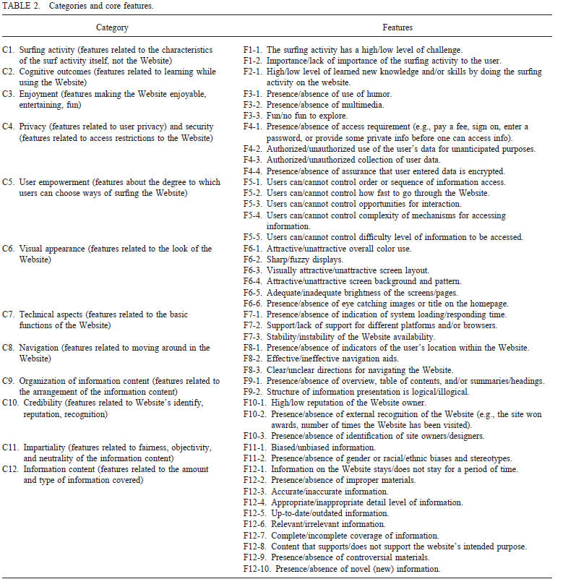

Pg1262

